t test(1s)

2024-02-19

df <- read.csv("Advertise.csv")  
summary(df)

## TV Radio Newspaper Sales   
## Min. : 8.6 Min. : 2.10 Min. : 1.00 Min. : 4800   
## 1st Qu.: 51.0 1st Qu.:13.35 1st Qu.: 20.15 1st Qu.:10050   
## Median :120.2 Median :27.70 Median : 46.00 Median :12500   
## Mean :124.1 Mean :26.24 Mean : 42.03 Mean :13939   
## 3rd Qu.:201.9 3rd Qu.:38.55 3rd Qu.: 58.45 3rd Qu.:18250   
## Max. :281.4 Max. :48.90 Max. :114.00 Max. :24400

boxplot(df$TV)

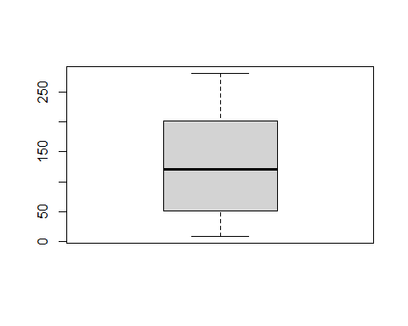 No outliers. H0: mean=30 H1: mean <>30 alpha=.05

t.test(df$TV, mu=30, alternative ="two.sided", conf=0.95)

##   
## One Sample t-test  
##   
## data: df$TV  
## t = 5.1493, df = 22, p-value = 3.673e-05  
## alternative hypothesis: true mean is not equal to 30  
## 95 percent confidence interval:  
## 86.22458 162.05368  
## sample estimates:  
## mean of x   
## 124.1391

t.test(df$TV, mu=30, alternative ="less", conf=0.95)

##   
## One Sample t-test  
##   
## data: df$TV  
## t = 5.1493, df = 22, p-value = 1  
## alternative hypothesis: true mean is less than 30  
## 95 percent confidence interval:  
## -Inf 155.532  
## sample estimates:  
## mean of x   
## 124.1391